LAB ASSIGNMENT – 4
Robot Framework Automation Exercises
Descriptive Lab Report – Screenshot Evidence Included as Placeholders
Assignment | 4 – Robot Framework
Framework | Robot Framework
Primary Libraries | SeleniumLibrary, RequestsLibrary
Execution / Parallel Tool | Robot Framework, Pabot
Evidence | Two screenshot spaces for each exercise

1. Problem Statement
Implement the Robot Framework exercises specified in the assignment to demonstrate keyword-driven browser automation, variables and data-driven execution, custom Python keywords and libraries, assertions and verification, test setup and teardown, tags and test execution, and reports and logs.

2. Objective
- Understand Robot Framework syntax, settings, variables, test cases and keywords.
- Automate browser interactions using SeleniumLibrary.
- Use variables and reusable test data in automation.
- Create and execute custom Python keywords.
- Perform assertions and API response verification.
- Demonstrate test setup and teardown.
- Use tags for selective execution and Pabot for parallel execution.
- Generate and inspect Robot Framework reports and logs.

3. Tools, Software and Concepts
- Python 3.x
- Robot Framework
- SeleniumLibrary
- RequestsLibrary
- Pabot
- Google Chrome
- ChromeDriver / Selenium Manager
- PowerShell or Command Prompt
- VS Code or PyCharm

4. Theory

4.1 Robot Framework
Robot Framework is a keyword-driven automation framework. Test cases are written in a readable tabular syntax and use libraries and keywords to perform automation tasks.

4.2 SeleniumLibrary
SeleniumLibrary provides browser automation keywords such as Open Browser, Input Text, Click Button and Page Should Contain Element.

4.3 Variables and Data-Driven Automation
Robot Framework variables allow values such as URLs, usernames and passwords to be defined separately from the test steps. Test templates can also execute the same keyword with different input data.

4.4 Custom Keywords and Libraries
Robot Framework can import Python modules and expose Python functions as custom keywords. This allows reusable Python functionality to be called directly from Robot test cases.

4.5 Assertions, Setup, Teardown and Tags
Assertions verify expected results. Test Setup prepares the environment before a test and Test Teardown performs cleanup. Tags classify tests so selected groups can be included or excluded during execution.

5. Project Structure
Assignment4_RobotFramework/
│
├── 01_basic.robot
├── 02_variables.robot
├── 03_data_driven.robot
├── 04_custom_keywords.robot
├── 05_assertions_api.robot
├── 06_setup_teardown.robot
├── 07_tags.robot
├── 08_reports.robot
│
└── custom_library.py

6. Installation and Verification
python -m pip install robotframework
python -m pip install robotframework-seleniumlibrary
python -m pip install robotframework-requests
python -m pip install robotframework-pabot
robot --version

7. Exercise 1 – Basic Syntax and Keywords
This exercise demonstrates basic Robot Framework syntax and browser keywords. The test opens the login page, enters a username, verifies the password field and closes the browser.
*** Settings ***
Library SeleniumLibrary
*** Test Cases ***
Open Page And Verify Element
Open Browser https://the-internet.herokuapp.com/login chrome
Maximize Browser Window
Input Text id=username tomsmith
Page Should Contain Element id=password
Log Username entered successfully
Sleep 10s
Close Browser
Execution command: robot 01_basic.robot
[ – Exercise 1 – Basic Syntax and Keywords ]
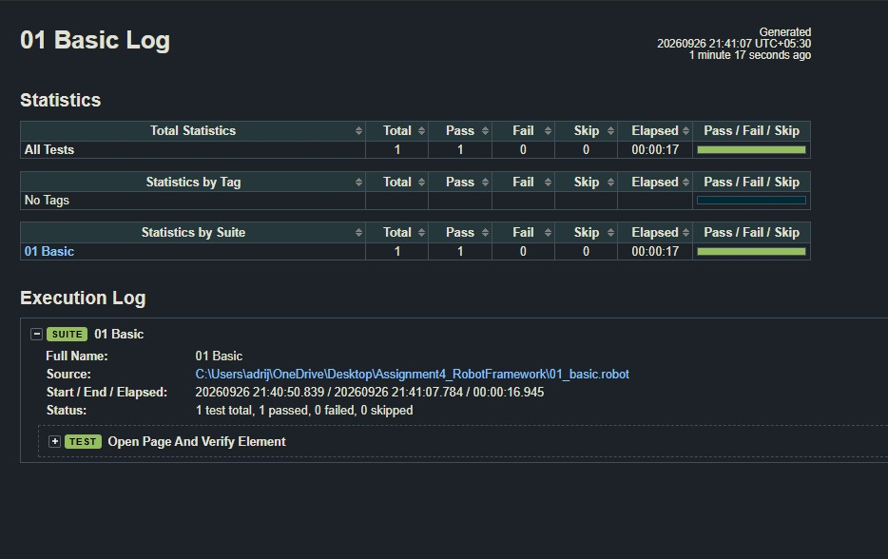
[ – Exercise 1 – Basic Syntax and Keywords – 2 ]
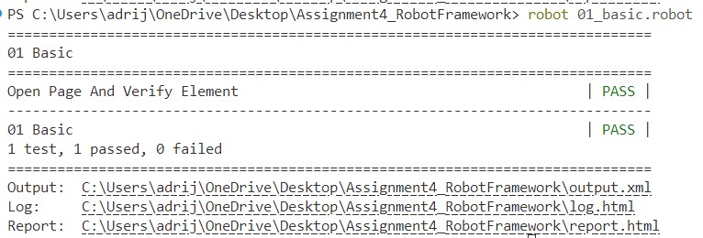

8. Exercise 2 – Variables and Data-Driven Automation
Variables are used for the URL and login credentials so that test data is separated from the test actions.
*** Settings ***
Library SeleniumLibrary
*** Variables ***
${URL} https://the-internet.herokuapp.com/login
${USERNAME} tomsmith
${PASSWORD} SuperSecretPassword!
*** Test Cases ***
Login Using Variables
Open Browser ${URL} chrome
Maximize Browser Window
Input Text id=username ${USERNAME}
Input Password id=password ${PASSWORD}
Click Button css=button[type="submit"]
Location Should Contain /secure
Log Login successful using variables
[Teardown] Close All Browsers

8.1 Data-Driven Version
*** Settings ***
Library SeleniumLibrary
Test Template Login Test
Test Teardown Close All Browsers
*** Test Cases ***
Valid Login
tomsmith SuperSecretPassword!
Invalid Login
wronguser wrongpassword
*** Keywords ***
Login Test
[Arguments] ${username} ${password}
Open Browser https://the-internet.herokuapp.com/login chrome
Input Text id=username ${username}
Input Password id=password ${password}
Click Button css=button[type="submit"]
Execution command: robot 02_variables.robot
[ – Exercise 2 – Variables and Data-Driven Automation ]
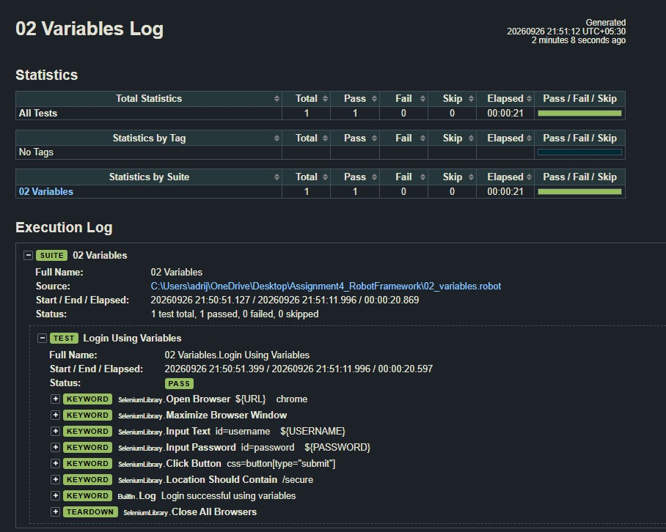
[ – Exercise 2 – Variables and Data-Driven Automation – 2 ]
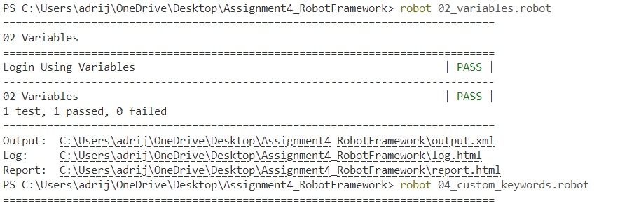

9. Exercise 3 – Custom Keywords and Libraries
A Python library is created to provide reusable Robot Framework keywords. The final version uses the String library for the Convert To Upper Case operation.
from robot.api.deco import keyword
@keyword("Calculate Sum")
def calculate_sum(a, b):
return float(a) + float(b)
@keyword("Multiply Numbers")
def multiply_numbers(a, b):
return float(a) * float(b)
*** Settings ***
Library custom_library.py
Library String
*** Test Cases ***
Use Custom Python Keyword
${sum}= Calculate Sum 12 8
Should Be Equal As Numbers ${sum} 20
Log Sum calculated successfully: ${sum}
Use String Library Keyword
${text}= Convert To Upper Case robot framework
Should Be Equal As Strings ${text} ROBOT FRAMEWORK
Log String operation completed successfully
Use Multiplication Keyword
${result}= Multiply Numbers 6 7
Should Be Equal As Numbers ${result} 42
Log Multiplication calculated successfully: ${result}
The earlier BuiltIn-only version of this exercise produced the error “No keyword with name 'Convert To Upper Case' found”. The corrected implementation imports the String library and should be used for the final evidence.
Execution command: robot 04_custom_keywords.robot
[ – Exercise 3 – Custom Keywords and Libraries ]
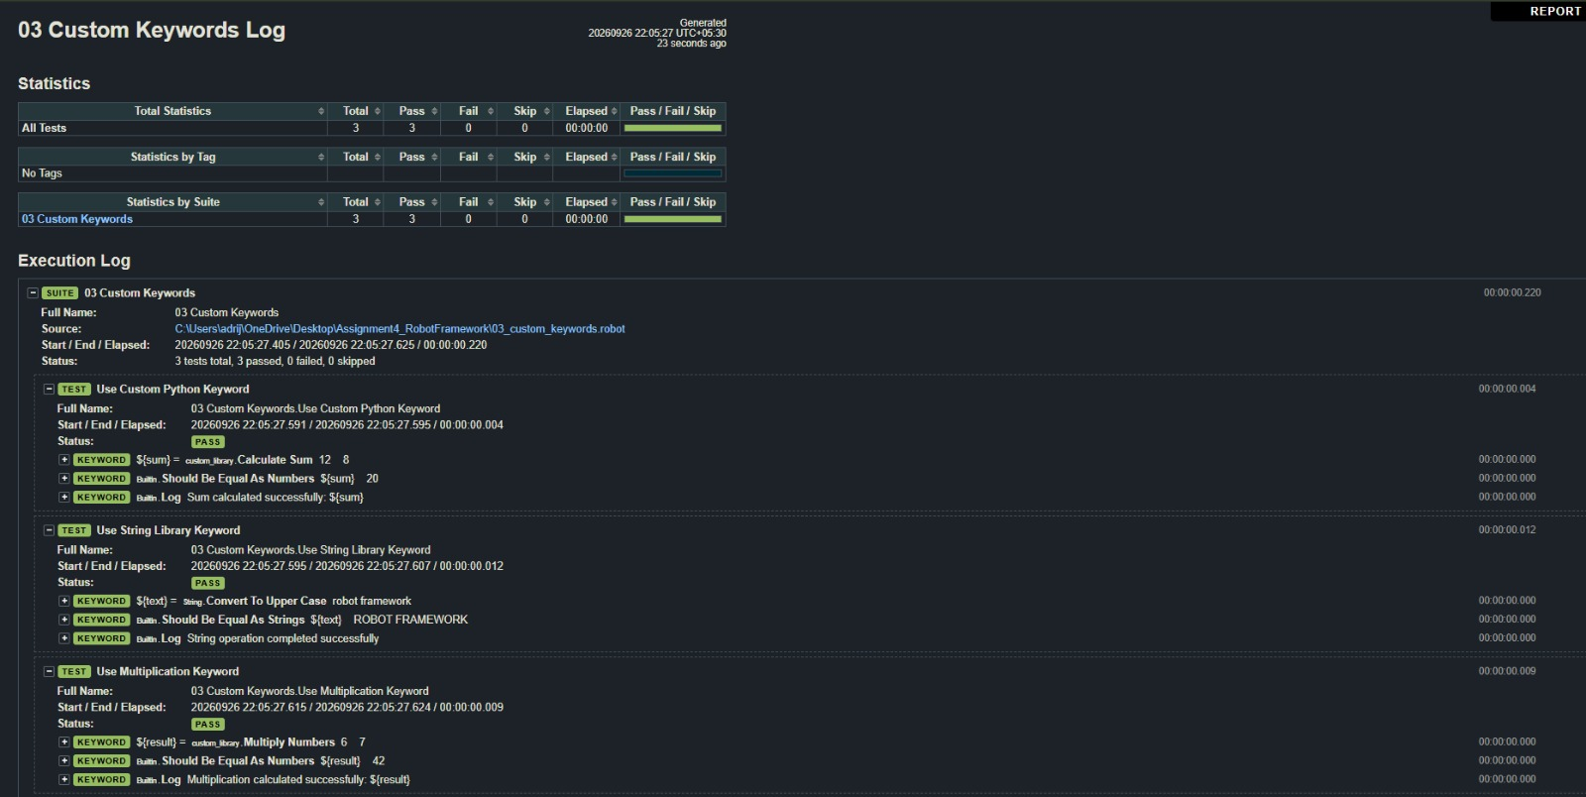

[– Exercise 3 – Custom Keywords and Libraries – 2 ]

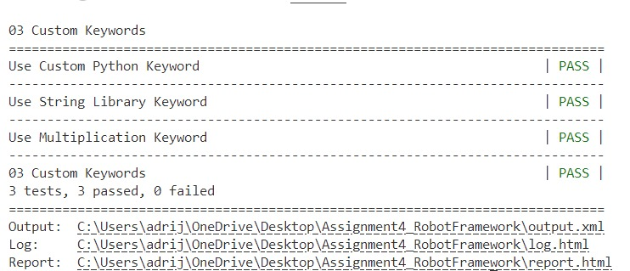

10. Exercise 4 – Assertions and Verification
This exercise verifies API status codes and response content using RequestsLibrary and Robot Framework assertions.
*** Settings ***
Library RequestsLibrary
*** Test Cases ***
Verify API Status
${response}= GET https://httpbin.org/status/200
Should Be Equal As Strings ${response.status_code} 200
Log API status verified successfully
Verify API Response
${response}= GET https://httpbin.org/get
Should Be Equal As Strings ${response.status_code} 200
Should Contain ${response.text} url
Log API response verification completed
Execution command: robot 05_assertions_api.robot
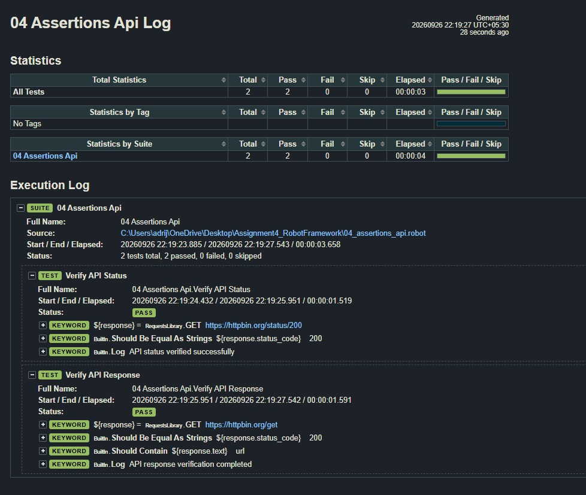
[– Exercise 4 – Assertions and Verification ]

[– Exercise 4 – Assertions and Verification – 2 ]

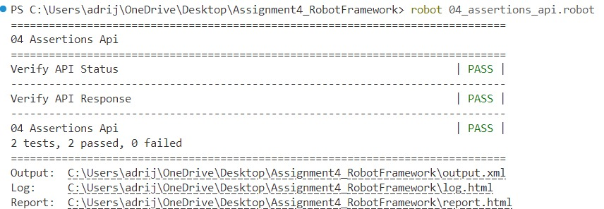

11. Exercise 5 – Test Setup and Teardown
Test Setup is executed before each test and Test Teardown is executed after each test. This example opens the login page before each test and closes all browsers afterward.
*** Settings ***
Library SeleniumLibrary
Test Setup Open Login Page
Test Teardown Close All Browsers
*** Keywords ***
Open Login Page
Open Browser https://the-internet.herokuapp.com/login chrome
Maximize Browser Window
*** Test Cases ***
Verify Username Field
Page Should Contain Element id=username
Verify Password Field
Page Should Contain Element id=password
Verify Login Button
Page Should Contain Element css=button[type="submit"]
Execution command: robot 06_setup_teardown.robot
[– Exercise 5 – Setup and Teardown ]
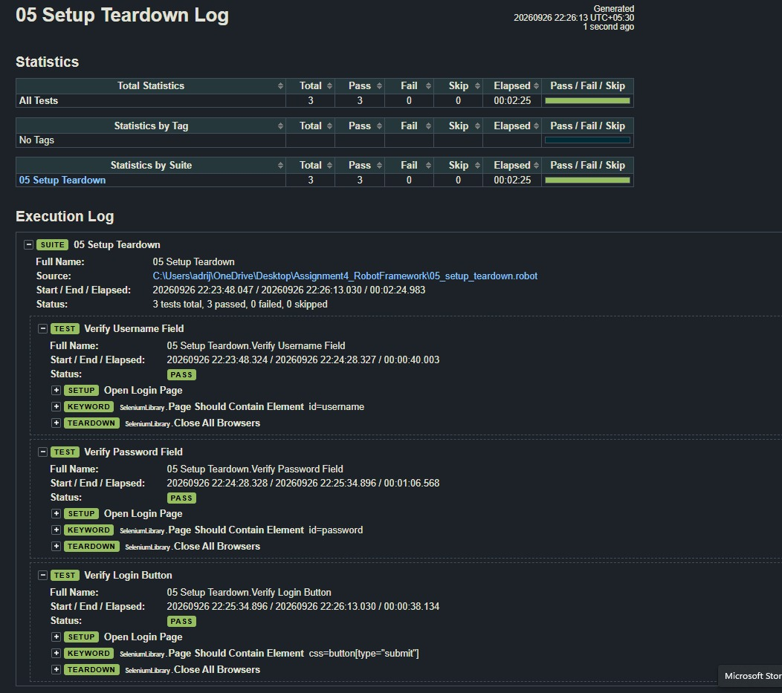

[– Exercise 5 – Setup and Teardown – 2 ]

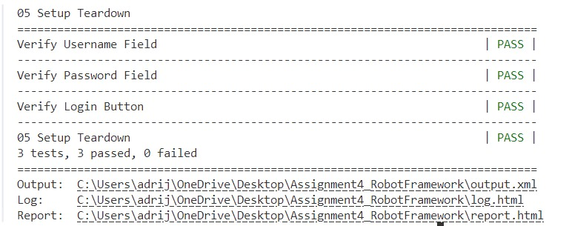

12. Exercise 6 – Tags and Test Execution
Tags classify tests and allow selected tests to be included or excluded. Pabot can be used for parallel Robot Framework execution.
*** Test Cases ***
Smoke Test
[Tags] smoke
Log Running Smoke Test
Regression Test
[Tags] regression
Log Running Regression Test
Critical Test
[Tags] critical
Log Running Critical Test
Smoke Login Test
[Tags] smoke login
Log Running Smoke Login Test
robot --include smoke 07_tags.robot
robot --exclude regression 07_tags.robot
robot --include critical 07_tags.robot
pabot --processes 2 07_tags.robot
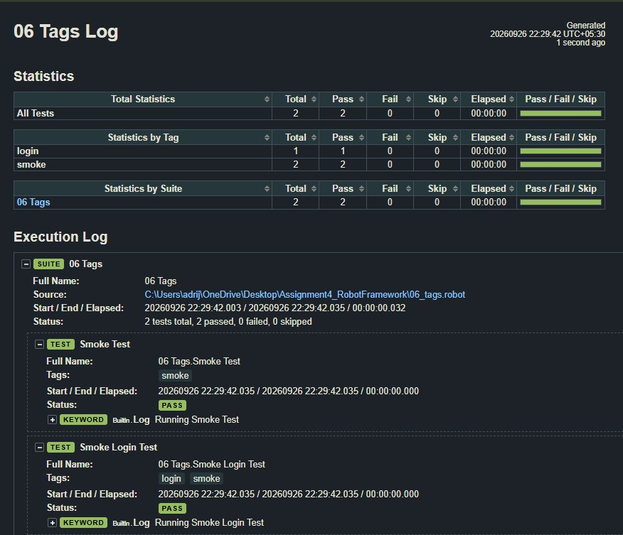
[– Exercise 6 – Tags and Test Execution ]

[ SCREENSHOT PLACEHOLDER – Exercise 6 – Tags and Test Execution – 2 ]
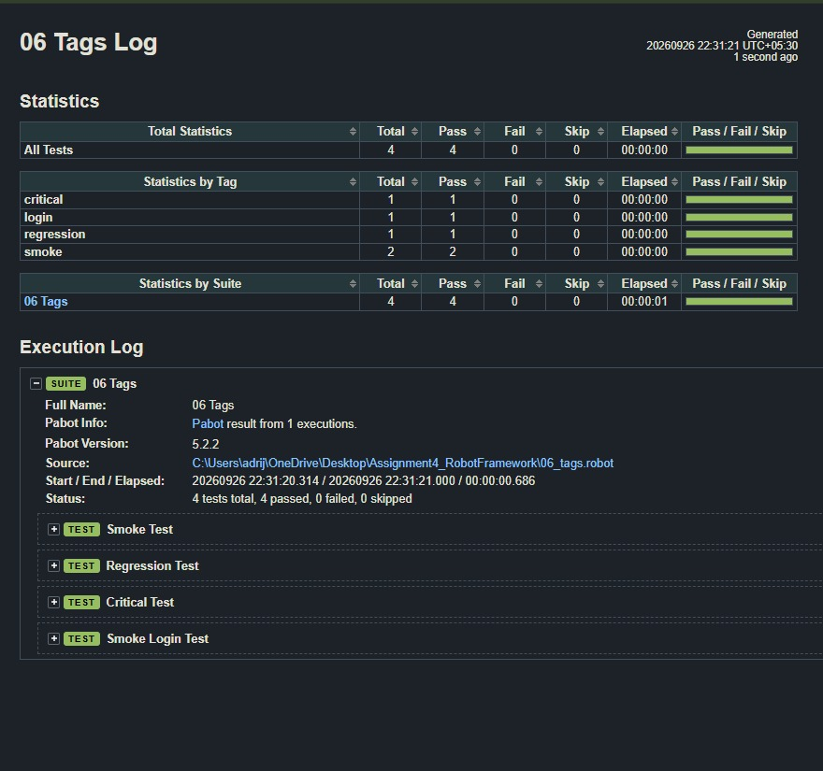

13. Exercise 7 – Reports and Logs
Robot Framework generates execution artifacts including output.xml, log.html and report.html. The output directory option can be used to keep the generated files together.
*** Settings ***
Library BuiltIn
*** Test Cases ***
Logging Demonstration
Log =================================
Log Test execution started
Log =================================
${value}= Evaluate 5 * 6
Log Calculated value: ${value}
Should Be Equal As Integers ${value} 30
Log Calculated value verified successfully
Log Test execution completed
mkdir results
robot --outputdir results 08_reports.robot
start .\results\report.html
start .\results\log.html

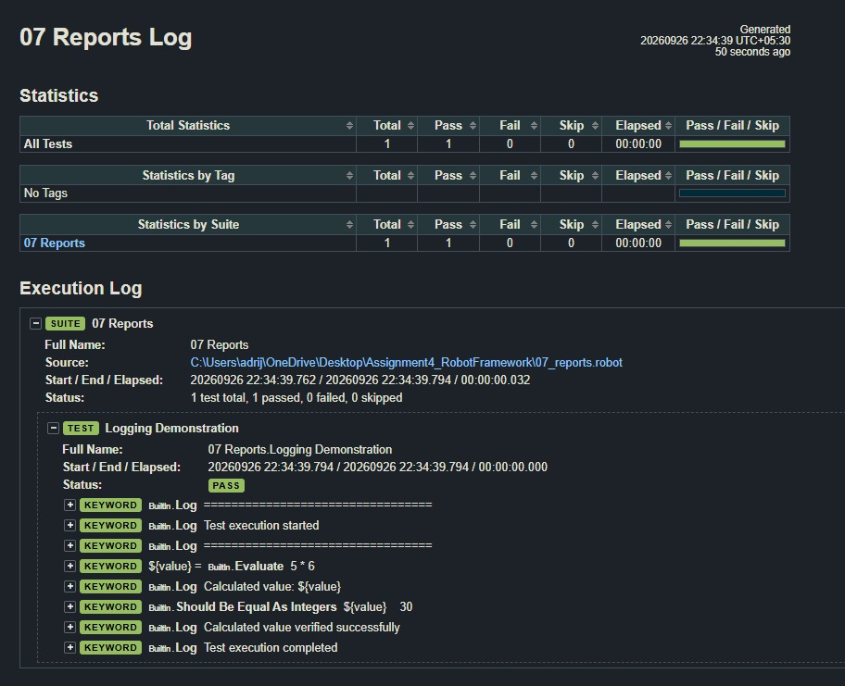
[– Exercise 7 – Reports and Logs ]

[– Exercise 7 – Reports and Logs – 2 ]
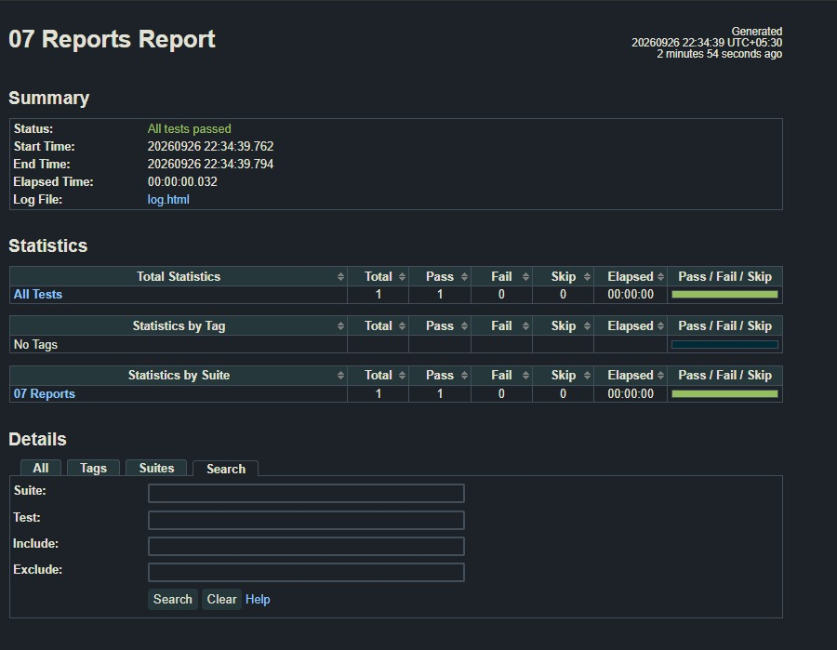

14. Screenshot Checklist
Each exercise has two reserved screenshot spaces. Recommended evidence is one screenshot for source/configuration or browser state and one screenshot for successful execution, log, report or generated output.
- Exercise 1 – Basic Syntax and Keywords: 2 screenshots
- Exercise 2 – Variables and Data-Driven Automation: 2 screenshots
- Exercise 3 – Custom Keywords and Libraries: 2 screenshots
- Exercise 4 – Assertions and Verification: 2 screenshots
- Exercise 5 – Setup and Teardown: 2 screenshots
- Exercise 6 – Tags and Test Execution: 2 screenshots
- Exercise 7 – Reports and Logs: 2 screenshots

15. Result
The Assignment 4 lab work is organized into seven Robot Framework exercise areas covering browser automation, variables and data-driven testing, custom libraries, assertions, test lifecycle management, execution tags, parallel execution, and reporting. Final execution results should be recorded after each exercise has been run successfully.

16. Observation
Robot Framework provides readable keyword-driven syntax and supports reusable libraries. The exercises demonstrate how browser actions, test data, Python functions, assertions, setup/teardown, tags and reporting can be combined in an automation workflow.

17. Conclusion
This assignment provides practical experience with Robot Framework and its supporting libraries. It demonstrates how automated tests can be structured using reusable keywords, externalized variables, custom Python functions, assertions, lifecycle controls, execution filters and generated reports.

